**Lab Session 11**



**Advanced Procedures**



**Objectives**

* Implementing procedures using stack frame
* Using stack parameters in procedures
* Passing value type and reference type parameters

**Stack Applications**

There are several important uses of runtime stacks in programs:

* A stack makes a convenient temporary save area for registers when they are used for more than one purpose. After they are modified, they *can* be restored to their original values.
* When the CALL instruction executes, the CPU saves the current subroutine’s return address on the stack.
* When calling a subroutine, you pass input values called arguments by pushing them on the stack.
* The stack provides temporary storage for local variables inside subroutines.

**Stack Parameters**

* **Passing by value**

When an argument is passed by value, a copy of the value is pushed on the stack..

**EXAMPLE:**

.data

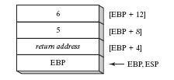 var1 DWORD 5

var2 DWORD 6

.code

push var2

push var1

call AddTwo

exit

AddTwo PROC

push ebp

mov ebp, esp

mov eax, [ebp + 12]

add eax, [ebp + 8]

pop ebp

ret

AddTwo ENDP

* **Explicit stack parameters**

When stack parameters are referenced with expressions such as [ebp+8], we call them explicit stack parameters.

**EXAMPLE:**

.data

var1 DWORD 5

var2 DWORD 6

y_param EQU [ebp + 12]

x_param EQU [ebp+ 8]

.code

push var2

push var1

callAddTwo

exit

AddTwo PROC

push ebp

mov ebp, esp

mov eax, y_param

add eax, x_param

pop ebp

ret

AddTwo ENDP

* **Passing by reference**

An argument passed by reference consists of the offset of an object to be passed.

**EXAMPLE:**

.data

count = 10

arr WORD count DUP (?)

.code

push OFFSET arr

push count

call ArrayFill

exit

ArrayFill PROC

push ebp

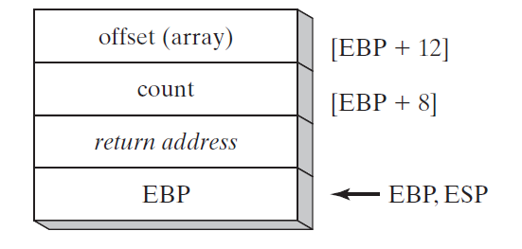 mov ebp, esp

pushad

mov esi, [ebp + 12]

mov ecx, [ebp + 8]

cmp ecx, 0

je L2

L1:

mov eax, 100h

call RandomRange

mov [esi], ax

add esi, TYPE WORD

loop L1

L2:

popad

pop ebp

ret 8

ArrayFill ENDP

**Local Variables**

In MASM Assembly Language, local variables are created at runtime stack, below the base pointer (EBP).

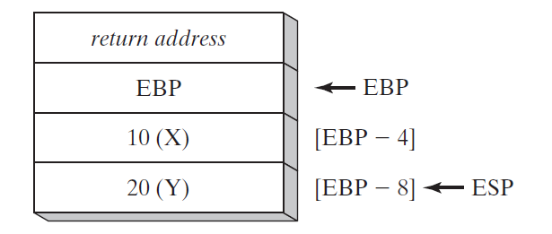**EXAMPLE:**

.code

call MySub

exit

MySub PROC

push ebp

mov ebp, esp

sub esp, 8

mov DWORD PTR [ebp - 4], 10 ; first parameter

mov DWORD PTR [ebp - 8], 20 ; second parameter

mov esp, ebp

pop ebp

ret

MySub ENDP

**LEA Instruction**

LEA instruction returns the effective address of an indirect operand. Offsets of indirect operands are calculated at runtime.

**EXAMPLE:**

.code

call makeArray

exit

makeArray PROC

push ebp

mov ebp, esp

sub esp, 32

lea esi, [ebp - 30]

L1:

mov BYTE PTR [esi], '*'

inc esi

loop L1

add esp, 32

pop ebp

ret

makeArray ENDP

**ENTER & LEAVE Instructions**

Enter instruction automatically creates stack frame for a called Procedure. Leave instruction reverses the effect of enter instruction.

**EXAMPLE:**

.data

var1 DWORD 5

var2 DWORD 6

.code

push var2

push var1

call AddTwo

exit

AddTwo PROC

enter 0, 0

mov eax, [ebp + 12]

add eax, [ebp + 8]

pop ebp

leave

ret

AddTwo ENDP

**LOCAL Directive**

LOCAL directive declares one or more local variables by name, assigning them size attributes.

**EXAMPLE:**

.code

call LocalProc

exit

LocalProc PROC

LOCAL temp : DWORD

mov temp, 5

mov eax, temp

ret

LocalProc ENDP

**Invoke Directive**





**Proc Directive**

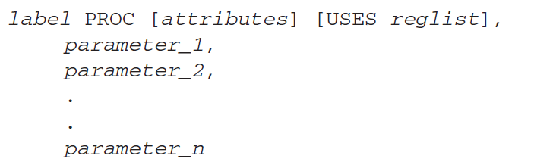

**ADDR Directive**



Using INVOKE and PROTO

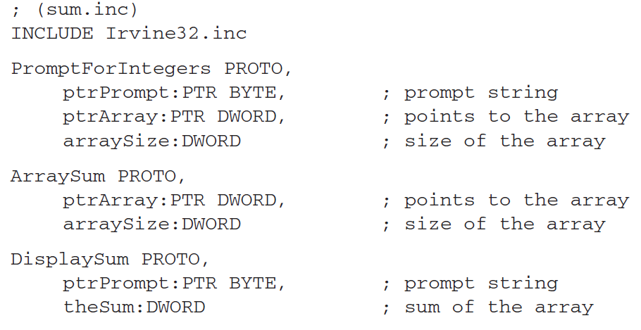

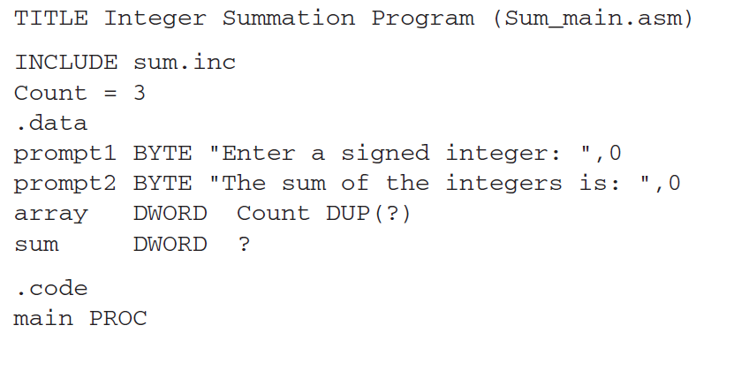

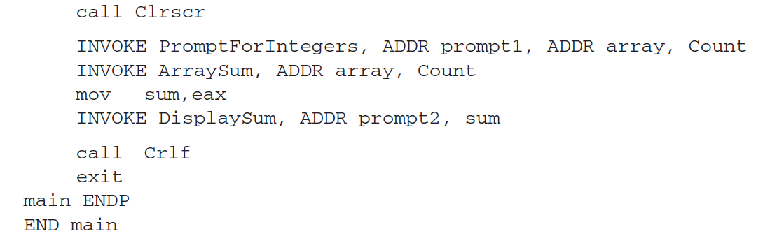

**Recursive Procedures**

Recursive procedures are those that call themselves to perform some task.

**EXAMPLE:**

.code

mov ecx, 5

mov eax, 0

call CalcSum

L1:

call WriteDec

call crlf

exit

CalcSum PROC

cmp ecx, 0

jz L2

add eax, ecx

dec ecx

call CalcSum

L2:

ret

CalcSum ENDP

**ACTIVITIES:**

1. Write a program which contains a procedure named **ThreeProd** that displays the product of three numeric parameters passed through a stack. Store the product and the variables in local variables inside the stack and clear it later on (Use Local directive to declare the variables). Use ENTER, LEAVE and USES variable as well. Clear the stack before returning from the procedure.

2. Write a program which contains a procedure named **MinMaxArray** that displays the minimum & maximum values in an array. Pass a size-20 array by reference to this procedure. Use ENTER and LEAVE directive as well.

3. Convert the following code in assembly language.

void duplicate (int& a, int& b, int& c)

{

a*=2;

b*=2;

c*=2;

}

int main ()

{

int x=1, y=3, z=7;

duplicate (x, y, z);

cout << "x=" << x << ", y=" << y << ", z=" << z;

return 0;

}

4. Code the following recursive function in assembly language

#include<stdio.h>

int fun(int a, int b)

{

   if (b == 0)

       return 0;

   if (b % 2 == 0)

       return fun(a+a, b/2);

   return fun(a+a, b/2) + a;

}

int main()

{

  printf("%d", fun(4, 3));

  getchar();

  return 0;

}